Ecomorphological patterns in otoliths of tropical fishes: can we call them functional traits?

Ivan Oliveira de Assis¹, Victor Emmanuel Lopes da Silva¹*, Alejandra Vanina Volpedo², Nídia Noemi Fabré¹

¹Laboratório de Ecologia, Peixes e Pesca – Universidade Federal de Alagoas, Campus A.C. Simões. Av. Lourival Melo Mota, Tabuleiro do Martins, 57072-970 Maceió, AL, Brasil.
I.O.A.: http://orcid.org/0000-0001-8703-9722 (ORCID-iD)
V.E.L.S.: http://orcid.org/0000-0002-7473-9591 (ORCID-iD) / <*corresponding author: lopesdasilvavictor@gmail.com>
N.N.F.: http://orcid.org/0000-0002-4954-2236 (ORCID-iD)

²Instituto de Investigaciones en Producción Animal – Universidad de Buenos Aires, Facultad de Ciencias Veterinarias. Av. Chorroarín 280, Buenos Aires 1427, Argentina.
A.V.V.: http://orcid.org/0000-0003-3321-311X (ORCID-iD)

Running title: Otolith ecomorphology as functional traits

Summary: Otolith shape has emerged as an important indicator of ecological characteristics of fish species. However, descriptors that can accurately predict well-documented functions played by species in ecosystems are still poorly known. Therefore, we evaluated the power of ecomorphological indexes patterns in otoliths in identifying trophic groups for fish species in tropical regions by linear discriminant analysis (LDA) and multivariate analysis of variance (MANOVA). Distinct patterns for each studied group could be identified, and 99% of total variability in otolith shape could be explained by the LDA function. Our results suggest that ecomorphological indexes of otoliths should be used as functional traits in future studies, as otolith shape provide a wider range of ecological information regarding feeding habitat, mobility, substrate association and water column use.

Key-words: ecological indicators, feeding habit, functional diversity, sagittae, surrogate.

INTRODUCTION
During the last decades, ecomorphology has emerged as a recurring and powerful tool in ecological studies (Norton et al. 1995; Volpedo and Echeverría 2003; Volpedo and Fuchs 2010). The identification of relationships between body structure’s shape and ecological functions and processes has provided some insights about some of the oldest issues in ecology, such as competitive and coevolution mechanisms, the arrangement of natural communities and the performance capability of species (Losos 1990; Motta et al. 1995). In fishes, for example, the eye size and length of digestive tract have been related to differences in foraging behavior (Soares et al. 2013), body shape has been used as a predictor of mobility of tropical species, elucidating assembly rules in communities of estuarine and reef fishes (Passos et al. 2016) and ecomorphological patterns in otoliths have helped to understand water-column use by species and association with different types of substrate (Volpedo and Echeverría 2003; Jaramilo et al. 2014).
Otoliths, in particular, have been shown as a good predictor of ecological characteristics of species due to their variability in form that may result from - or be associated to - many factors (Schulz-Mirbach et al. 2006), such as substrate type (Volpedo and Cirelli 2006), feeding habit (Nonogaki et al. 2007), ontogenetic shifts (Pérez and Fabré 2013) and phylogeny (Avigliano et al. 2015). These calcium carbonate structures are located in the inner ear of fishes, being formed and shaped throughout the life-history of species by depositions of calcium carbonate from the saturated fluid (Secor et al. 1992). Although it has been discussed by many authors that otolith shape is a species-specific feature of organisms, as a result of phylogenetic history of species (Wilson 1985), new studies have shown that it may also reflect patterns in the use of resources and habitats by different groups (Aguirre and Lombarte 1999; Nonogaki et al. 2007), making the morphology of these structures a descriptor of roles that organisms play within ecosystems (Tuset et al. 2016).
Nevertheless, the use of otolith morphology as a functional trait – features that strongly influences organismal performance and/or individual fitness (McGill et al. 2006) – is fairly new (Tuset et al. 2016), and a lot of questions surrounding this subject remains unsolved. For example, it is still poorly known which descriptors of otolith shape are related to well-documented functions played by fishes in ecosystems, such as trophic position (Tuset et al. 2015). According to Gagliano and McCormick (2004), difficulties in determining patterns that may reflect feeding history of species is due to complex processes that influence otolith growth and shape. However, the identification of patterns in otolith shape that can be linked to this function might be a key element in the advance of new approaches for functional ecology (Tuset et al. 2016), especially for species in tropical regions where studies of feeding ecology are often difficult to be carried out (Nonogaki et al. 2007).
Therefore, the present study aims to test whether and which ecomorphological indexes of otoliths are a good predictor of fish trophic position. Specifically, we used discriminant analysis to study the power of otolith morphological patterns in discriminate different feeding habit among tropical fishes.

MATERIALS AND METHODS
Otolith preparation and ecomorphological indexes
We sampled 353 otoliths of 22 species collected along the coast of Alagoas, located in the tropical south-west Atlantic ecoregion of the north-east Brazil. In laboratory, fishes were identified at level species using regional taxonomic keys (Figueiredo and Menezes 1978, 1980, Menezes and Figueiredo 1980, 1985), measured to the nearest mm (total length) and sexed. Otoliths were removed using the open-the-hatch technique as described by Secor et al. (1992), cleaned from tissues with 5% NaOH, washed with distilled water, dried and stored in labeled vials. To avoid the effect of ontogenetic variability, only otoliths from sexually mature specimens were used in this study (Stransky and MacLellan 2005), hence, maturity stage of individuals was assigned using macroscopic gonadal examination following Vazzoler (1996).
A digital picture of each otolith was taken using a binocular microscope Leica S8-APO equipped with a camera Leica EC3. Otoliths were always positioned with their respective dorsal margin to the top of the image and anterior (rostral) region to the left. The following morphometrical measurements were record in millimeters (mm) for all otoliths using the image processing system – ImageJ (Rasband 1997): otolith length (OL), otolith width (OW), otolith area (OA), otolith perimeter (OP), rostrum length (RL) and sulcus area (SA). We then calculated four ecomorphological indexes (see Table 1 for details) to identify patterns in otolith form: the E, R and S indexes which describe otolith shape and dimensions (Volpedo and Echeverría 2003; Volpedo et al. 2008), and an edge complexity index (EC) based on Kalff’s shoreline development factor (SFD), typically used to describe shoreline irregularities (Kalff 2002).

Data analysis
Prior analysis, fishes were assigned to a trophic group (based on the main diet of adults) according to existing published data (Table 2). To promote uniformity in the classification of species, the categories used herein followed Ferreira et al. (2004): carnivorous (fishes that feed on other animals); mobile invertebrate feeders (fishes that only feed on mobile invertebrates); omnivorous (fishes that feed on a variety of food items, including planktonic, benthonic and nektonic organisms) and piscivorous (fishes that feed mainly on other fish species)
A linear discriminant analysis (LDA) was carried out to test whether ecomorphological patterns in otoliths were a good predictor of trophic guilds. LDA reduces the ratio of within-class variance and maximizes the ratio of between-class variance, seeking directions on space that have maximum discriminability among given classes (Rezzi et al. 2007), making this analysis a powerful tool in the identification of groups. We also performed a multivariate analysis of variance (MANOVA) to test significant differences in indexes among classes, and the pairwise Hotelling's test was applied to identify groups which differed significantly. All statistical analyses were performed in the software R statistics at a significance level of p<0.05.

RESULTS
According to the linear discriminant analysis (LDA) and the multivariate analysis of variance (MANOVA) results, ecomorphological patterns in otoliths are a good predictor of fish trophic groups (Wilks’ λ = 0.03, p<0.05). Evidence of significant differences in otoliths’ shape among guilds could be observed graphically (Fig. 1). LDA explained 99% of the total variance, and the indexes EC, E and R were the best discriminators between assigned classes (Fig. 1).
Mean percentage of accurate classification of species to their appropriate feeding habit with the LDA model (jackknife cross-validation) reached 90% (Table 3). In function of misclassifications and according to the post-hoc analysis results, the otoliths of piscivorous and omnivorous species were the most similar among studied guilds (Table 3 and 4). These two groups showed a more complex otolith shape and a tendency towards a rectangular/oblong form, whereas the otoliths of carnivorous and mobile invertebrate feeders exhibited a more circular shape with low edge complexity (Table 5).

DISCUSSION
The relationship between otolith morphology and trophic position of species found in our study suggest a functional interpretation of these structures. According to Violle et al. (2007), a functional trait is characterized as a feature that strongly influence organisms’ performance and fitness, being directly related to ecological functions played by species within ecosystems. However, in many groups the identification of these features in field and laboratory conditions is difficult to be done, being necessary, in most cases, the utilization of surrogates (Hugueny and Pouilly 1999; Gibb et al. 2015). In fishes, for example, morphological relationships between body structures have been widely used in functional studies as an indicator of feeding habit of species (Dolbeth et al. 2016; Passos et al. 2016; Silva-Júnior et al. 2016) once trophic studies are typically hard to be carried out (Nonogaki et al. 2007). Nonetheless, there has been a huge debate on whether these “soft traits” would accurately reflect trophic position of species, with many authors arguing that morphology is not always capable of identify plasticity in feeding behavior of organisms, therefore, providing unduly information (Vitt and Pianka 2005).
In this respect, it is not surprising that the search for structures that can provide more consistent data for functional studies has been the aim of many current works (Keck et al. 2014; Villéger et al. 2017). The core challenge is that most morpho-anatomical traits are only capable of discriminate groups without assessing fine-scale aspects of fish diet (Albouy et al. 2011), thus expressing only the potential or fundamental niche of species. This happens, in part, because species that present similar body shapes may have different mechanisms for food acquisition and consumption (Konow and Bellwood 2011), showing a weak relationship between body shape and diet (Albouy et al. 2011). Moreover, phylogeny play an important role in the shaping of body structures, making species in the same genus and/or family share similar features even when presenting different ecological behaviors (Peres-Neto 2004; Oliveira et al. 2010).
In our study, however, ecomorphological patterns in otoliths were a good predictor of trophic groups, with species clustering together regardless their variability in body shape and phylogenetic relationships, indicating that these structures can retain a wider range of ecological information in their form. For example, even though the three studied carangid species in our paper have a close phylogenetic relationship and resembling body structures, they were all clustered separately, being placed near to species that share similar feeding habits. Comparable results were found for Tuset et al. (2016), that analyzed otolith morpho-geometry of Mediterranean fishes in order to test these structures as predictors of functional biodiversity. Authors found that otolith morphology provide better interpretation of ecological functions played by species within ecosystems than fish shape (Tuset et al. 2016). Factors that allow morphological patterns in otoliths to accurately reflect ecological characteristics of species include their lack of extreme morphologies – which strongly influence ecomorphological indexes – (Tuset et al. 2016), and the fact that otolith shape is a species-specific feature formed throughout fish life-history (Wilson 1985), which permit them to retain information regarding habitat use, locomotion, mobility and feeding behavior (Volpedo and Echeverría 2003; Lombarte and Cruz 2007; Volpedo et al. 2008).
In our analyses, the indexes related to shape (E), rostrum length (R) and edge complexity (EC) of otoliths were the best discriminators of trophic groups. Otolith shape and rostrum length has been widely discussed in literature as an indicate of water column use and association of different types of substrate (Volpedo and Echeverría 2003), with species capable of high mobility presenting a long-elongated otolith and well-developed rostrum. Such results are comparable with our data, as piscivorous and omnivorous species presented otoliths with a tendency towards a more elongated shape and a rostrum occupying almost all its extension (Fig. 1 and Table 5). This pattern found for both groups may be related to species’ dependence on greater swimming performance to obtain food items and the fact that their preys are often found in the middle of the water column, which require them to present some adaptative aspects of a high luminosity and noisy pelagic environment near the sea surface (Begg and Hopper 1997; Paxton 2000; Lombarte and Cruz 2007). Furthermore, the highly edge complexity found for piscivorous and omnivorous species may be associated to greater levels of food consumption, as it has been shown by studies that otolith lobes’ formation depends on the protein accretion process (Hüssy 2008).
On the other hand, carnivorous and mobile invertebrate feeders were characterized by otoliths with circular shape, regular edges and a smaller or not-developed rostrum. In both groups, species feed mainly on organisms associated with the substrate – eg.: crustaceous, polychaetas –, which do not require them to move up in the water column (Crabtree et al. 1998; Marques et al. 2009).
In summary, our results show that ecomorphological patterns in otoliths are not only a good predictor of trophic position of tropical fishes, but also provide a wider range of information regarding the feeding strategies and habitat use by species, which are all required information to estimate the functional structure of assemblages. Therefore, we conclude that ecomorphological indexes that are associated to the shape, rostrum length and edge complexity of otoliths should be included in future studies as functional traits in order to obtain a more realistic picture of how functionally diversity communities are.

ACKNOWLEDGMENTS
We would like to thank colleagues C. Passos, M. Sousa, R. Costa and V. Batista for their assistance during field and laboratory work. This research was funded by the Brazilian Natonal Council for Scientfc and Technological Development – CNPq (N. Fabré, grant #306624/2014-1) and the Coordination for the Improvement of Higher Education Personnel – CAPES. Data collection and analysis was funded by a grant from the State Funding Agency of Alagoas (FAPEAL) and the Brazilian Ministry of Fisheries and Aquaculture (MPA).

REFERENCES
Adams A., Guindon K., Horodysky A., MacDonald T., McBride R., Shenker J., Ward R. 2012. Albula nemoptera. Available from http: //dx.doi.org/10.2305/IUCN.UK.2012.RLTS.T190357A1949274.en.
Aguirre H., Lombarte A. 1999. Ecomorphological comparisons of sagittae in Mullus barbatus and M. surmuletus. J. Fish Biol. 55: 105–114.
Akadje C., Diaby M., Le Loc’h F., Konan J.K., N’Da K. 2013. Diet of the barracuda Sphyraena guachancho in Côte d’Ivoire (Equatorial Eastern Atlantic Ocean). Cybium. 37: 285–293.
Albouy C., Guilhaumon F., Villéger S., Mouchet M., Mercier L., Culioli J.M., Tomasini J.A., Le Loc’h F., Mouillot D. 2011. Predicting trophic guild and diet overlap from functional traits: statistics, opportunities and limitations for marine ecology. Mar. Ecol. Prog. Ser. 436: 17–28.
Avigliano E., Jawad L.A., Volpedo A. V. 2015. Assessment of the morphometry of saccular otoliths as a tool to identify triplefin species (Tripterygiidae). J. Mar. Biol. Assoc. United Kingdom.: 1–14.
Begg G.A., Hopper G.A. 1997. Feeding patterns of school mackerel (Scomberomorus queenslandicus) and spotted mackerel (S. munroi) in Queensland east-coast waters. Mar. Freshw. Res. 48: 565–571.
Bessa E., Santos F.B., Pombo M., Denadai M., Fonseca M., Turra A. 2014. Population ecology, life history and diet of the shorthead drum Larimus breviceps in a tropical bight in southeastern Brazil. J. Mar. Biol. Assoc. United Kingdom. 94: 615–622.
Bowman R.E., Stillwell C.E., Michaels W.L., Grosslein M.D. 2000. Food of northwest Atlantic fishes and two common species of squid. NOAA Tech. Memo. NMFS-NE-155.
Chaves P.D.T.D.C., Umbria S.C. 2003. Changes in the diet composition of transitoty fishes in costal systems, estuary and continental shelf. Brazilian Arch. Biol. Technol. 46: 41–46.
Crabtree R.E., Stevens C., Snodgrass D., Stengard F.J. 1998. Feeding habits of bonefish, Albula vulpes, from the waters of the Florida Keys. Fish. Bull. 96: 754–766.
Denadai M.R., Santos F.B., Bessa E., Fernandez W.S., Lorca L., Turra A. 2013. Population biology and diet of Pomadasys corvinaeformis (Perciformes: Pomadasyidae) in Caraguatatuba Bay, southeastern Brazil. Rev. Biol. Trop. 61: 1947–1954.
Denadai M.R., Santos F.B., Bessa E., Fernandez W.S., Paschoal C.C., Turra A. 2012. Diets of Eucinostomus argenteus (Baird & Girard, 1855) and Diapterus rhombeus (Cuvier, 1829) (Perciformes: Gerreidae) in Caraguatatuba Bay, Southeastern Brazil. Panam. J. Aquat. Sci. 7: 143–155.
DeVane J.C. 1978. Food of king mackerel, Scomberoomorus cavalla, in Onslow Bay, North Carolina. Trans. Am. Fish. Soc. 107: 583–586.
Dolbeth M., Vendel A.L., Pessanha A., Patrício J. 2016. Functional diversity of fish communities in two tropical estuaries subjected to anthropogenic disturbance. Mar. Pollut. Bull. 112: 244–254.
Duque-Nivia G., Acero P. A., Santos-Martinez A., Rubio E.R. 1996. Food habits of the species of the genus Oligoplites (Carangidae) from the Cienaga Grande de Santa Marta-Colombian Caribbean. Cybium. 20: 251–260.
Estrada M. 1986. Habitos alimentarios de los peces del genero Haemulon (Pisces: Haemulidae) de los arrecifes de la region de Santa Marta, Colombia. An. Inst. Investig. Mar. 15–16: 49–66.
Ferreira C.E.L., Floeter S.R., Gasparini J.L., Ferreira B.P., Joyeux J.C. 2004. Trophic structure patterns of Brazilian reef fishes: a latitudinal comparison. J. Biogeogr. 31: 1093–1106.
Figueiredo J.L., Menezes N. 1978. Manual de Peixes Marinhos do Sudeste do Brasil. II. Teleostei (1). São Paulo: Museu de Zoologia, Universidade de São Paulo.
Figueiredo J.L., Menezes N. 1980. Manual de Peixes Marinhos do Sudeste do Brasil. III. Teleostei (2). São Paulo: Museu de Zoologia, Universidade de São Paulo.
Gagliano M., McCormick M.I. 2004. Feeding history influences otolith shape in tropical fish. Mar. Ecol. Prog. Ser. 278: 291–296.
Gibb H., Stoklosa J., Warton D.I., Brown A.M., Andrew N.R., Cunningham S.A. 2015. Does morphology predict trophic position and habitat use of ant species and assemblages? Oecologia. 177: 519–531.
Hugueny B., Pouilly M. 1999. Morphological correllates of diet in an assemblage of West African freshwater fishes. J. Fish Biol. 54: 1310–1325.
Hüssy K. 2008. Otolith shape in juvenile cod (Gadus morhua): Ontogenetic and environmental effects. J. Exp. Mar. Bio. Ecol. 364: 35–41.
Jaramilo A.M., Tombari A.D., Benedito Dura V., Eugeni Rodrigo M., Volpedo A. V. 2014. Otolith eco-morphological patterns of benthic fishes from the coast of Valencia (Spain). Thalassas. 30: 57–66.
Kalff J. 2002. Limnology: inland water ecosystems. New Jersey: Prentice Hall.
Keck B.P., Marion Z.H., Martin D.J., Kaufman J.C., Harden C.P., Schwartz J.S., Strange R.J. 2014. Fish functional traits correlated with environmental variables in a temperate biodiversity hotspot. PLoS One. 9.
Kehrig H.A., Seixas T.G., Di Beneditto A.P.M., Malm O. 2013. Selenium and mercury in widely consumed seafood from South Atlantic Ocean. Ecotoxicol. Environ. Saf. 93: 156–162.
Konow N., Bellwood D.R. 2011. Evolution of high trophic diversity based on limited functional disparity in the feeding apparatus of marine angelfishes (f. Pomacanthidae). PLoS One. 6.
Lombarte A., Cruz A. 2007. Otolith size trends in marine fish communities from different depth strata. J. Fish Biol. 71: 53–76.
Losos J.B. 1990. Ecomorphology, performance capability, and scaling of west Indian Anolis Lizards: an evolutionary analysis. Ecol. Monogr. 60: 369–388.
Marques J.F., Teixeira C.M., Pinheiro A., Peschke K., Cabral H.N. 2009. A multivariate approach to the feeding ecology of the Channel flounder, Syacium micrurum (Pisces, Pleuronectiformes), in Cape Verde, Eastern Atlantic. Ciencias Mar. 35: 15–27.
McGill B.J., Enquist B.J., Weiher E., Westoby M. 2006. Rebuilding community ecology from functional traits. Trends Ecol. Evol. 21: 178–185.
Mendoza-Carranza M., Vieira J. 2008. Whitemouth croaker Micropogonias furnieri (Desmarest, 1823) feeding strategies across four southern Brazilian estuaries. Aquat. Ecol. 42: 83–93.
Menezes N., Figueiredo J.L. 1980. Manual de Peixes Marinhos do Sudeste do Brasil. IV. Teleostei (3). São Paulo: Museu de Zoologia, Universidade de São Paulo.
Menezes N., Figueiredo J.L. 1985. Manual de Peixes Marinhos do Sudeste do Brasil. V. Teleostei (4). São Paulo: Museu de Zoologia, Universidade de São Paulo.
Motta P.J., Clifton K.B., Hernandez P., Eggold B.T. 1995. Ecomorphological correlates in ten species of subtropical seagrass fishes: diet and microhabitat utilization. Environ. Biol. Fishes. 44: 37–60.
Nonogaki H., Nelson J.A., Patterson W.P. 2007. Dietary histories of herbivorous loricariid catfishes: evidence from δ13C values of otoliths. Environ. Biol. Fishes. 78: 13–21.
Norton S.F., Luczkovich J.L., Motta P.J. 1995. The role of ecomorpholgical studies in the comparative biology of fishes. Environ. Biol. Fishes. 44: 287–304.
Oliveira E.F., Goulart E., Breda L., Minte-Vera C.V., de Paiva L.R.S., Vismara M.R. 2010. Ecomorphological patterns of the fish assemblage in a tropical floodplain: effects of trophic, spatial and phylogenetic structures. Neotrop. Ichthyol. 8: 569–586.
Passos C.V.B., Fabré N.N., Malhado A.C.M., Batista V.S., Ladle R.J. 2016. Estuarization increases functional diversity of demersal fish assemblages in tropical coastal ecosystems. J. Fish Biol. 89: 847–862.
Paxton J.R. 2000. Fish otoliths: do sizes correlate with taxonomic group, habitat and/or luminescence? Philos. Trans. R. Soc. Biol. Sci. 355: 1299–1303.
Peres-Neto P.R. 2004. Patterns in the co-occurrence of fish species in streams: the role of site suitability, morphology and phylogeny versus species interactions. Oecologia. 140: 352–360.
Pérez A., Fabré N.N. 2013. Spatial population structure of the Neotropical tiger catfish Pseudoplatystoma metaense: skull and otolith shape variation. J. Fish Biol. 82: 1453–1468.
Pombo M., Denadai M.R., Bessa E., Santos F.B., de Faria V.H., Turra A. 2014. The barred grunt Conodon nobilis (Perciformes: Haemulidae) in shallow areas of a tropical bight: spatial and temporal distribution, body growth and diet. Helgol. Mar. Res. 68: 271–279.
Rasband W.S. 1997. ImageJ. National Institutes of Health: Bethesda. .
Rezzi S., Giani I., Heberger K., Al. E. 2007. Classification of gilthead sea bream (Sparus aurata) from 1H NMR lipid profiling combined with principal component and linear discriminant analysis. J. Agric. Food Chem. 55: 9963–9968.
Schulz-Mirbach T., Reichenbacher B., Yildirim M.Z., Atalay M.A. 2006. Otolith characteristics of species, subspecies, and populations of Aphanius Nardo, 1827 (Teleostei, Cyprinodontiformes) from Anatolia (Turkey). J. Nat. Hist. 40: 1687–1705.
Secor D.H., Dean J.M., Laban E.H. 1992. Otolith removal and preparation for microstructural examination. In: Stevenson D.K., Campana S.E., editors. Otolith Microstructure Examination and Analysis. Canadian Special Publication of Fisheries and Aquatic Sciences 117. Ottawa: Departament of Fisheries and Oceans. p. 19–57.
Silva-Júnior C.A.B., Mérigot B., Lucena-Frédou F., Ferreira B.P., Coxey M.S., Rezende S.M., Frédou T. 2016. Functional diversity of fish in tropical estuaries: A traits-based approach of communities in Pernambuco, Brazil. Estuar. Coast. Shelf Sci.: 1–8.
Sley A., Jarboui O., Ghorbel M., Bouain A. 2009. Food and feeding habits of Caranx crysos from the Gulf of Gabès (Tunisia). J. Mar. Biol. Assoc. United Kingdom. 89: 1375–1380.
Soares B.E., Ruffeil T.O.B., Montag L.F. de A. 2013. Ecomorphological patterns of the fishes inhabiting the tide pools of the Amazonian Coastal Zone, Brazil. Neotrop. Ichthyol. 11: 845–858.
Stransky C., MacLellan S.E. 2005. Species separation and zoogeography of redfish and rockfish (genus Sebastes) by otolith shape analysis. Can. J. Fish. Aquat. Sci. 62: 2265–2276.
Tuset V.M., Farré M., Otero-Ferrer J.L., Vilar A., Morales-Nin B., Lombarte A. 2016. Testing otolith morphology for measuring marine fish biodiversity. Mar. Freshw. Res. 67: 1037–1048.
Tuset V.M., Imondi R., Aguado G., Otero-Ferrer J.L., Santschi L., Lombarte A., Love M. 2015. Otolith patterns of rockfishes from the northeastern pacific. J. Morphol. 276: 458–469.
Vazzoler A.E.A.M. 1996. Biologia da reprodução de peixes teleósteos: teoria e prática. Maringá: Maringá: EDUEM.
Vega-Cendejas M.E., Mexicano-Cíntora G., Arce A.M. 1997. Biology of the thread herring Opisthonema oglinum (Pisces: Clupeidae) from a beach seine fishery of the Campeche Bank, Mexico. Fish. Res. 30: 117–126.
Villéger S., Brosse S., Mouchet M., Mouillot D., Vanni M.J. 2017. Functional ecology of fish: current approaches and future challenges. Aquat. Sci. 79: 783–801.
Violle C., Navas M.L., Vile D., Kazakou E., Fortunel C., Hummel I., Garnier E. 2007. Let the concept of trait be functional! Oikos. 116: 882–892.
Vitt L.J., Pianka E.R. 2005. Deep history impacts present-day ecology and biodiversity. Proc. Natl. Acad. Sci. U. S. A. 102: 7877–7881.
Volpedo A., Echeverría D.D. 2003. Ecomorphological patterns of the sagitta in fish on the continental shelf off Argentine. Fish. Res. 60: 551–560.
Volpedo A. V., Fuchs D. V. 2010. Ecomorphological patterns of the lapilli of Paranoplatense Siluriforms (South America). Fish. Res. 102: 160–165.
Volpedo A. V., Tombari A.D., Echeverría D.D. 2008. Eco-morphological patterns of the sagitta of Antarctic fish. Polar Biol. 31: 635–640.
Volpedo A. V, Cirelli A.F. 2006. Otolith chemical composition as a useful tool for sciaenid stock discrimination in the south-western Atlantic. Sci. Mar. 70: 325–334.
Wilson R.R. 1985. Depth-related changes in sagitta morphology in six Macrourid fishes of the Pacific and Atlantic Oceans. Copeia. 4: 1011–1017.
Zahorcsak P., Silvano R. a, Sazima I. 2000. Feeding biology of a guild of benthivorous fishes in a sandy shore on south-eastern Brazilian coast. Rev. Bras. Biol. 60: 511–518.

Table 1. Ecomorphological indexes used to identify patterns in otoliths of tropical fishes collected in the south-west Atlantic.
Indexes | Meaning | Formula | Reference
EC | Describes edge irregularities in otoliths | 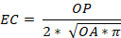 | (Kalff 2002)
E | Expresses the tendency in the shape of the sagittae (circular or elongate) | 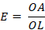 | (Volpedo and Echeverría 2003)
R | Expresses how much of the otolith length that corresponds to the rostrum | 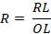 | (Volpedo and Echeverría 2003)
S | Tendency of macula nervous to have a greater surface area of information uptake to transmit to the fish brain | 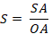 | (Volpedo et al. 2008)

Table 2. Average ecomorphological indexes values for species collected in the south-west Atlantic and their respective trophic guild.
Family / Species | N | Ecomorphological indexes |  |  |  | Trophic guild
Family / Species | N | EC | E | R | S | Trophic guild
Albulidae
Albula nemoptera | 3 | 1.12 | 0.42 | 0 | 0.35 | Carnivorous¹
Albula Vulpes | 30 | 1.11 | 0.45 | 0 | 0.40 | Carnivorous²
Carangidae
Caranx crysos | 21 | 1.22 | 0.38 | 0.27 | 0.31 | Piscivorous³
Chloroscombrus chrysurus | 39 | 1.08 | 0.46 | 0.30 | 0.30 | Omnivorous⁴
Oligoplites saurus | 4 | 1.37 | 0.58 | 0 | 0.62 | Carnivorous⁵
Clupeidae
Opisthonema oglinum | 30 | 1.20 | 0.46 | 0.35 | 0.43 | Omnivorous⁶
Gerreidae
Diapterus rhombeus | 30 | 1.27 | 0.70 | 0 | 0.25 | Carnivorous⁷
Eucinostomus argenteus | 19 | 1.15 | 0.65 | 0 | 0.29 | Carnivorous⁷
Haemulidae
Conodon nobilis | 7 | 1.05 | 0.65 | 0 | 0.26 | Carnivorous⁸
Haemulon aurolineatum | 16 | 0.95 | 0.70 | 0.15 | 0.23 | Mobile invertebrate feeders⁹
Haemulon steindachneri | 2 | 0.96 | 0.71 | 0.14 | 0.27 | Mobile invertebrate feeders¹⁰
Haemulopsis corvinaeformis | 30 | 0.98 | 0.71 | 0 | 0.28 | Mobile invertebrate feeders¹¹
Orthopristis ruber | 10 | 0.93 | 0.60 | 0.15 | 0.28 | Mobile invertebrate feeders¹²
Lutjanidae
Lutjanus synagris | 11 | 0.56 | 0.98 | 0 | 0.23 | Carnivorous⁹
Paralichthyidae
Syacium micrurum | 10 | 0.66 | 0.68 | 0 | 0.12 | Mobile invertebrate feeders¹³
Sciaenidae
Cynoscion jamaicensis | 2 | 1.35 | 0.47 | 0 | 0.52 | Carnivorous¹⁴
Larimus breviceps | 31 | 1.03 | 0.65 | 0 | 0.46 | Mobile invertebrate feeders¹⁵
Menticirrhus americanos | 11 | 1.27 | 0.41 | 0 | 0.51 | Carnivorous¹⁶
Micropogonias furnieri | 34 | 1.18 | 0.74 | 0 | 0.47 | Mobile invertebrate feeders¹⁷
Scombridae
Scomberomorus brasiliensis | 5 | 1.57 | 0.51 | 0.23 | 0.33 | Piscivorous¹⁸
Scomberomorus cavala | 3 | 1.19 | 0.52 | 0.23 | 0.37 | Piscivorous¹⁹
Sphyraenidae
Sphyraena guachancho | 5 | 1.30 | 0.35 | 0.43 | 0.35 | Piscivorous²⁰
¹(Adams et al. 2012); ²(Crabtree et al. 1998); ³(Sley et al. 2009); ⁴(Chaves and Umbria 2003); ⁵(Duque-Nivia et al. 1996); ⁶(Vega-Cendejas et al. 1997); ⁷(Denadai et al. 2012); ⁸(Pombo et al. 2014); ⁹(Ferreira et al. 2004); ¹⁰(Estrada 1986); ¹¹(Denadai et al. 2013); ¹²(Zahorcsak et al. 2000); ¹³(Marques et al. 2009); ¹⁴(Kehrig et al. 2013); ¹⁵(Bessa et al. 2014) ; ¹⁶(Bowman et al. 2000) ; ¹⁷(Mendoza-Carranza and Vieira 2008) ; ¹⁸(Begg and Hopper 1997); ¹⁹(DeVane 1978); ²⁰(Akadje et al. 2013)

Table 3. Jack-knifed classification matrix for the LDA of studied fish trophic groups (Carn: carnivorous; MIF: mobile invertebrate feeders; Omn: omnivorous; Pisc: piscivorous; Plank: planktivorous).
 | Carn | MIF | Omn | Pisc | Correctly classified (%)
Carn | 9 | 0 | 0 | 0 | 100%
MIF | 0 | 7 | 0 | 0 | 100%
Omn | 0 | 0 | 2 | 0 | 100%
Pisc | 0 | 0 | 2 | 2 | 50%

Table 4. Pairwise Hotelling's test results for studied fish trophic groups (Carn: carnivorous; MIF: mobile invertebrate feeders; Omn: omnivorous; Pisc: piscivorous; Plank: planktivorous).
 | Carn | MIF | Omn | Pisc
Carn
MIF | 0.001***
Omn | 0.013* | 0.06
Pisc | 0.001*** | 0.002** | 0.74
* p<0.05; ** p<0.01; *** p<0.001

Table 5. Variability in otolith shape of each studied trophic group (Carn: carnivorous; MIF: mobile invertebrate feeders; Omn: omnivorous; Pisc: piscivorous; Plank: planktivorous).
 | Trophic group
 | Carn | MIF | Omn | Pisc
- 2 s.d. | 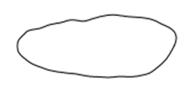 | 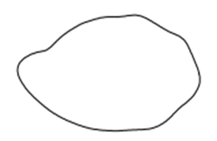 | 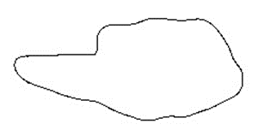 | 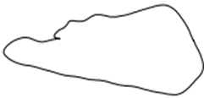
Mean | 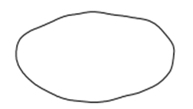 | 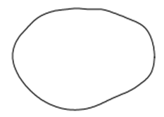 | 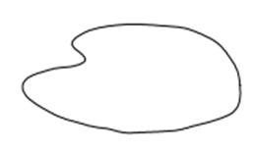 | 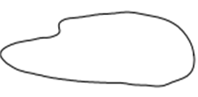
+ 2 s.d. | 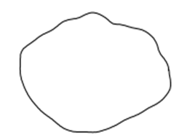 | 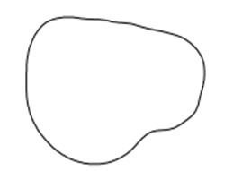 | 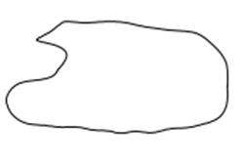 | 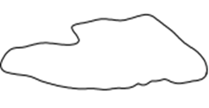

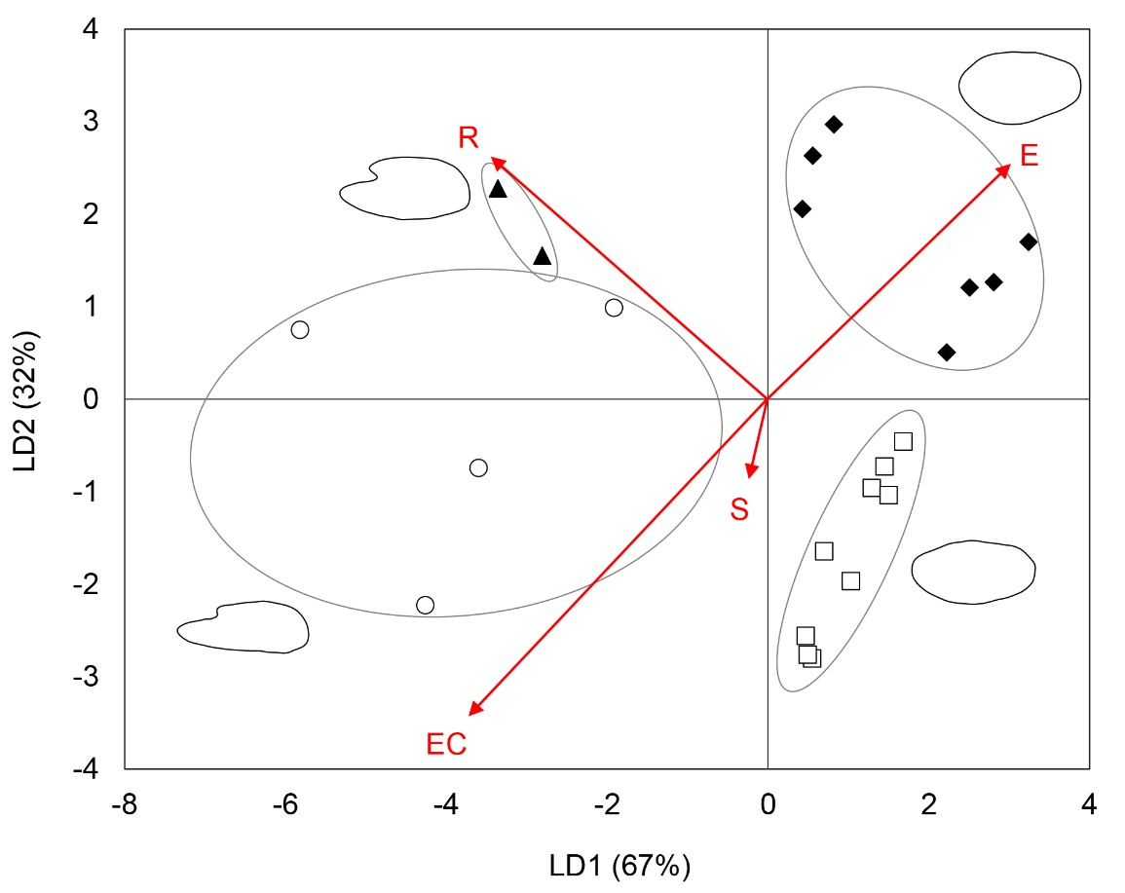
Figure 1. Results of LDA of ecomorphological indexes calculated for otoliths of studied fish species. Bi-dimensional plot of canonical scores, each point indicate a species (□ = carnivorous; ♦ = mobile invertebrate feeders; ▲= omnivorous; ○ = piscivorous) and arrows show indexes and their contribution to total dissimilarity.

